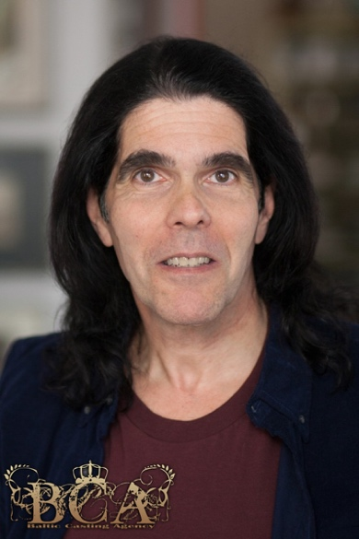 M2393

Height: 5’10” Weight: 175lbs.

**FILM**

THE FULL MASTI Blackwater (Principal) Orient Productions

UNEASY Andreas (Principal) 125 Productions

CREEPY TALES OF NYC Lamia, King of Evil (Principal) Heredia Films, LLC

TAFFY WAS BORN Ty O’Neal (Principal) Taffy Inc.

**NEW YORK STAGE**

THE DAY AFTER THAT Ensemble w/ Liza Minnelli, Billy Stritch

SHARON Guarder Mooney w/ Geraldine Fitzgerald

CSI: VERONA Lord Capulet MTR Repertory Theatre

PRIVATE LIVES Elyot Players Club

ALL’S WELL THAT ENDS WELL King of France NYC Fringe Festival

MUCH ADO ABOUT NOTHING Leonato MTR Repertory Theatre

LIFE WITH YIA-YIA One-Man Show Manhattan Repertory Theatre

THE LOWER DEPTHS The Baron Pulse Theatre

**COMMERCIALS AND VOICE OVER DEMOS -** *list available upon request*

**TRAINING**

Voice-Over Technique David Zema New York, NY

On-Camera Technique Tom Grail TGR Studios, New York, NY

On-Camera Technique Barry Shapiro SAG-AFTRA Conservatory

Acting/Scene Study Howard Jensen Indiana University

Acting/Scene Study Susan Slavin New York, NY

Voice/Diction Marion Michael Indiana University

Movement/Dance Gates McFadden Pittsburgh Playhouse

Master Class Mandy Patinkin New York, NY

Master Class Geraldine Fitzgerald New York, NY

Singing Laura Imperia New York, NY

**SPECIAL SKILLS**

**Fluent in French, Russian, Greek**; Accents and Regional Dialects; Spokesperson; Teacher of: Voice and Diction, Accent Reduction, Speech, English as a Second Language; Facile with Medical Terminology; Teleprompter; Excellent Mimic and Vocal Impressionist (including celebrities); Voice (High Baritone) Improvisation; Masks; Comaedia del Arte, Valid US Passport