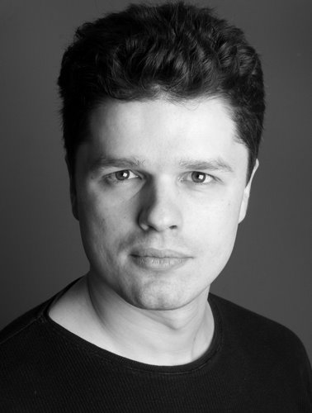**M2568**

Height: 5’11 Build: athletic Hair: brown Eyes: hazel Equity member

**Training** Actors Centre (London)

**Feature Films** *Role Company/ Director*

Bourne 5 Eric Universal Pictures/ Paul Greengrass

Anna Karenina Andrei Universal Pictures/ Joe Wright

W.E. David Kingsley Semtex Films/ Madonna

Hugo Cabret Sam Turner Perdido & Johnny Depp Films/ Martin Scorsese

Brides Sailor Alexis Martin Scorsese/ Pantelis Voulgaris

Nine John Blake Weinstein Company/ Rob Marshall

The Imaginarium of Dr Parnassus Willie Sony Pictures Classics/ Terry Gilliam

Prince of Persia Jordan Ahriman Universal Pictures/ Mike Newell

Hippie Shake Eric Dunk Universal Pictures/ Beeban Kidron

Telstar Jeff Scannell Aspiration Films/ Nick Moran

Miss Pettigrew Lives for a Day Tom Wright Phenomenon Pictures/ Bharat Nalluri

S.N.U.B! Convict S.N.U.B. Productions/ Jonathan Glendening

Nightlights & Sunrise Dan Stewart Socrates Productions/ Marty Mcnerney

The Looser Takes All George Greek Film Centre/ Nikos Nikolaides

Across The Border Ivan Independent/ Gaia Giafferi

Life Charlie Independent

**Theatre**

Othello Iago Theatro Technis/ George Evgeniou

Aphrodite & the Apple King Menelaus Boscombe Arts Centre/ Christina Artemis

The Boyfriend Marcel Milfield Theatre/ Amanda Noar

Trojan Women Talthibius Tour in Greece & Cyprus/ Antonis Antipas

Good Guys Marios Theatro Technis/ George Evgeniou

MYPN, Through My Eyes Suitor Tour in London/ Carlota Bermudez

Two for the Seesaw Jerry Theater Of Changes/ Helena Mirtsofska

**Television**

The Hour Sound Mixer BBC/ Jaime Paine

Eastenders Tim Floyd BBC/ Peter Rose

The Bill Richard ITV/ Barry Davis

Holby City Adam Tucker BBC/ Rob Evans

City Exposed James Barry BBC/ Joanna Burge

Johnny Vaughan Show Chris White BBC/ Nick Corey-Wright

Bremner & Fortune Dimitri Yakovlev Vera/ Steeve Connelly

He Kills Coppers Café Owner BBC/ Rob Evans

Katy Brand Show James World’s End/ Chris Faith

True Stories Casino Dealer Channel Five/ Chris Mitchell

**Commercials**

Setting the Standards Stephen NSPCC/ Dave Ward

Army Refugee 2AM Films/ Paul Goldman

Crimestoppers Boyfriend Amarillo Films/ David Baksh

**Accents** Bilingual in English (RP, Standard American) and Greek, French (very good), Spanish (good)

**Skills** Served with the Greek armed forces, Strong singer, tenor saxophone, keyboards & piano, gymnastics, sailing, swimming, stage fight, voice overs, clean driving license, journalist

**Interviews** Hornsey & Crouch End Journal, NET TV channel news broadcast, EGO! Weekly magazine, Espresso newspaper, Dimokratia newspaper, Alpha TV channel news broadcast, ‘Made in Star’ (Star TV), Avecnews, Star TV news broadcast.