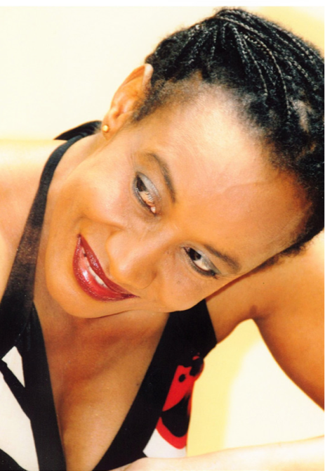 **M3213**

Short Films Producer, Stage Producer, Actress, Author, Playwright, Choreographer, Entrepreneur

Internationally renowned and multi-award winning artist Sheela is one of the most prolific multi media artists in Australia today, as well as one of its most prized artistic and cultural treasures.

Born, raised and educated in Kilimanjaro, Tanzania, with additional studies in Scandinavia, she now makes Adelaide, her home and the new center of her worldwide creative ventures.

Sheela has produced short animation films, several stage productions for all ages, several music albums and videos, written numerous books, and has toured around the globe. Her vibrant, captivating performances are the reason that she’s continually adding new venues to her already frequent repeat appearances, year after year.

Sheela’s creativity is matched only by her inexhaustible on- stage energy, as she often tours with 2-3 productions at one time. Intertwined with her demanding performance schedule, Sheela conducts immensely popular dance/drama workshops, using her own deep and unique writing style, and movement mastery to inspire participants to birth their own unique artistic self-expression.