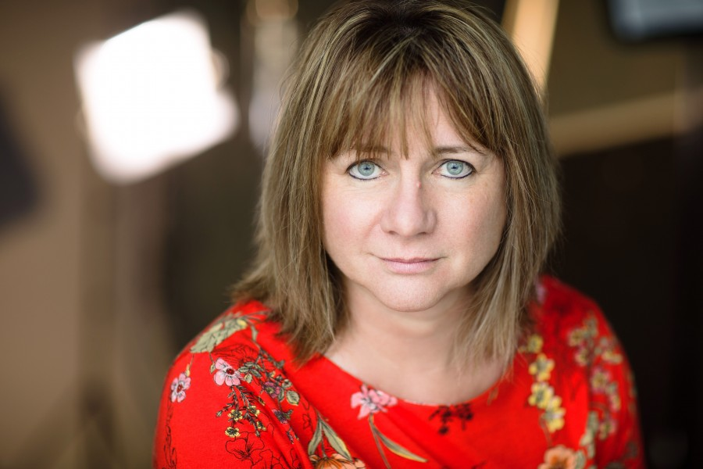

STAGE

A MIDSUMMER NIGHT’S DREAM (Hippolyta/Oberon) Dir. Mark France. Well-Fangled Theatre 2016

BLONDE (Gladys Baker) Dir. Helen Brown. Travesti Theatre, 2015

OLEANNA (John: re-gendered), Dir. Helen Brown. Travesti Theatre, 2013

ELECTRA (Clytemnestra), Dir. Helen Brown. Travesti Theatre, 2012

DESERT MONOLOGUES (Lady Macbeth), Dir. Kemsley Dickinson. Drama Dubai, 2009.

ROMEO & JULIET (Chorus), Dir. Andrew Manley. Harrogate Theatre, 1991

ROLE PLAY ACTOR (UK and Dubai) Freelance role-play actor and facilitator

FILM/COMMERCIALS

SAFE SPACE (Maggie). Short Film. Dir. Ben S Hyland. Hidden Art Films, 2017

RESCUE! (Sandy) Commercial. Dir. Ajay Arora. Nodachi, 2017

THE WISH AND THE WISP (Mary’s mother). Feature Film. Dir. Vashmere Valentine. SudieDot Productions, 2017

SEEN and HEARD (Jackie). Short Film. Dir. Chris Goodwin. White Boat TV, 2016

RADIO & VOICE OVER

PRESENTER, Coast & County Radio
VOICE OVER ARTIST - Vast range of clients across all genres including IVR, audiobook, corporate & e-learning, commercials, drama and documentary narration

M3994

TEACHING & WRITING

AUTHOR, ZigZag Education
- Practitioners: Joan Littlewood: A Complete Guide for AS & A Level
- Practitioners: Punchdrunk: A Complete Guide for AS & A Level

SECONDARY TEACHING
- 10+ years teaching Drama & Theatre Studies English, Media & Film to A level.
- Directing credits: ‘One for the Road’, ‘A Doll’s House’, ‘Shakers’ and ‘a host of devised performances
- Former Head of Careers, Assistant Head of VIth Form and Assistant Housemistress of St Bede’s House, Ampleforth College, UK

PRIVATE TEACHING - Impressive track record teaching Speech & Drama to teenagers and adults to LTCL diploma level

EDUCATION and SKILLS

FTCL (Fellowship, Trinity College London) Performing: Speech & Drama

PGCE English, Open University

BA (Hons) Drama, University of Bristol

VOMASTERCLASS, Gary Terzza, London

WORKSHOPS attended include Trestle, Frantic Assembly, Actors of Dionysus and Flying Cloud Theatre

TECHNOLOGY – WP, sound recording and editing, presentation software such as Powerpoint/Prezi, social media

