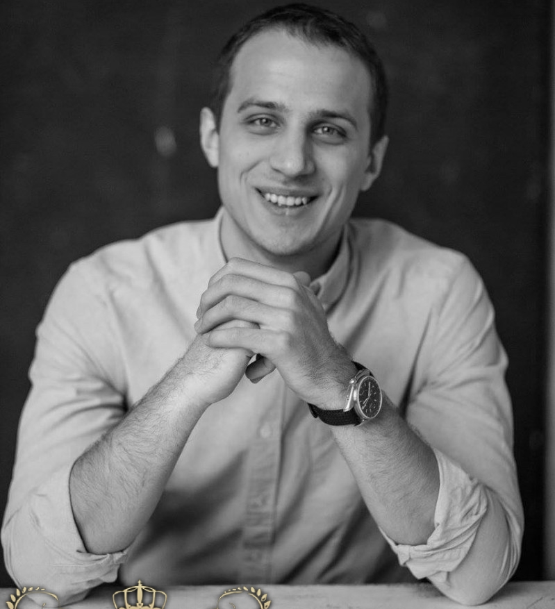
ID M3695
Height: 6'2" Weight: 192 Hair: Brown
Eyes: Green/Blue
FILM:
Hush! dir. Anna Patarakina Man
Crime and Punishment dir. Altynaim Khatran Raskolnikov
TELEVISION:
Prison Break (Russian remake) dir. Andrey Malyukov Student
Don't Lie To Me dir. Dmitriy Larin Son , Stas
The witnesses dir. Igor Romashenko Ruslan
Morozova dir. Ivan Shegolev Lieutenant
COMMERCIAL:
Sprite commercial Wind Direction Detector
Google commercial Man
PROFESSIONAL THEATRЕ EXPERIENCE:
2017 Camden Fringe Festival; "If We could Rewrite History" by Samantha Garman, Dillon
2014-2016 Troupe Member of Moscow Drama Theater headed by Armen Dzhigarkhanyan Roles: Shakespeare's "Romeo and Juliette", Romeo; Goldoni's "The Mistress of the Inn", Fabrizio; Gorin's "A Plague on both Your Houses", Valentin; Radzinsky's "Theater in the Time of Neron and Seneca", Murderer; Ribchinsky's "The White Crow" (musical), Soldier/Citizen/Guard/Monk
SKILLS/INTERESTS: Theatre, movies, swimming, soccer, fencing, roller blading, bike riding, running, baseball, adventures, fluent Russian, Belorussian, Ukrainian and English

EDUCATION: Russian University of Theatrical Art-GITIS

