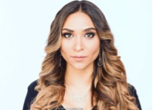 **M3553   
  
Height:** 5’8 **Weight:** 122 lbs **Hair:** Ombre   **Eyes:** Hazel/Green **Ethnicity:** Azerbaijani (Ethnically Ambiguous)

