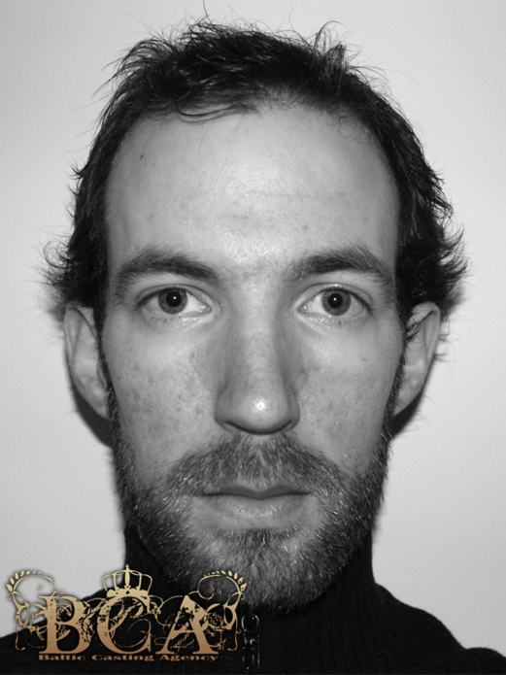 M3513
Height: 181 cm Eye color: Blue Hair color: Brown
