M3447

FILMS
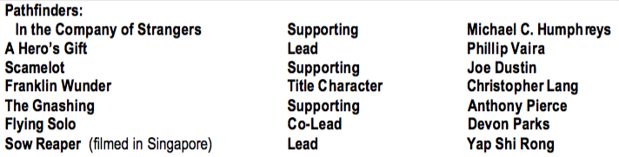
Theatre
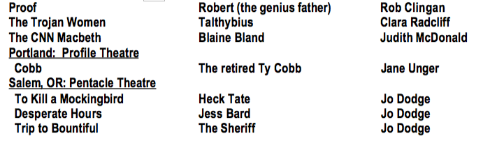

TELEVISION - VIDEO
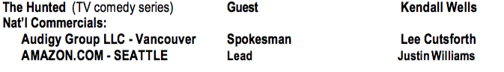
RADIO
Stage and On-Air Announcer Nashville’s GRAND ‘OLE OPRY
TRAINING
