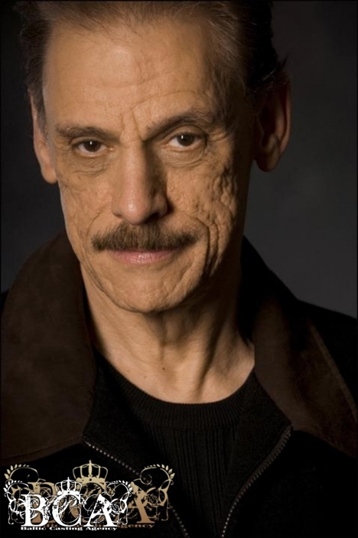 **M3429   
  
Height: 6' 2" Weight: 197 lbs Eyes: Brown Suit size: 42 long Shoe size: 13   
Hair: Brown**

