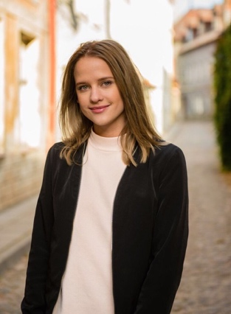
M3352

born: 19. December 1997

Education

2014-2017 | Nesodden High School
 | Media and communication

Experience
2017
July 13 Sony – Background actor
2016
March 16  October 30  2015  January 28  March 7 | Music video - klovner i kamp ”Min aller beste venn”  Music video - Mats Wawa - Ecuador  Music video - Kappekoff ”Slippin”  Music video – Ian Bel ”Cling to hope”
Languages

Norwegian
Estonian
English

