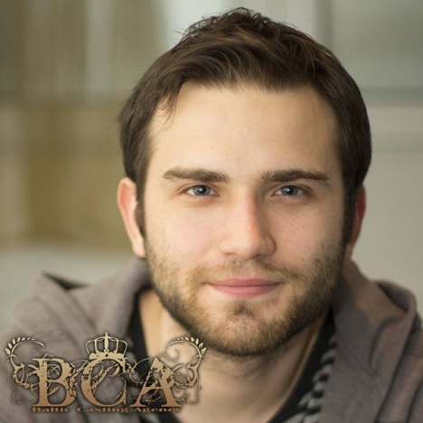 M3332

Eyes: Blue Height: 180 cm Hair: Dark Brown Weight: 65 kg
Project: Role: Director/Production:
Life Lessons (Tv Show) PAVEL/ Support Constantin Entertainment
ING (Commercial) Dog owner/Lead Multimedia Est
Herman Ltt.Maj.Corbeanu/Featured Victoria Baltag
Palatul Pionierilor Razvan/Featured Bobby Paunescu
Sesiunea (short) Mircea/Supporting Claudiu Voroneanu
Inelul (short) Pictorul/Lead Gabriel Boholt
Acolo, atunci (short) Matei/Lead Razvan Ionescu
GRINDCORE (short) Vlad/Lead Ioachim Ciobanu
Winner, Audience Award, Dakino Int’l Film Festival 2014
Juramantul lui Hippocrate (short) Seargent Sorin/Featured Dorin Panea
Fantezie in Do Minor (short) Marian/Featured Rares Stoica
Uciga-l Sfantu’ (short) The Keyboard Player/Supporting Ioachim Ciobanu
Cel mai bun (short) Victima/Lead Razvan Ionescu
Start (short) The Gamer/Lead Radu Tiganas Ultimul om de pe pamant (short) Dmitry/Lead Vlad Marinescu
Happy Meal (short) Baltag/Supporting Andrei Mazareanu
Winner, Audience Award, Galati Int’l Film Festival 2011
Adolescentul confuz (short) Adolescentul/Lead Ioachim Ciobanu
Shooting the shit (short) Mihai /Lead Radu Tiganas
Runner Up, Best Film Award, TimiShort Film Festival 2011
Director
Deadbeat

Writer
Deadbeat
Grindcore
Sarbatori Fericite
Hyperfest International Student Film Festival Organiser/Selector, 2016 – present
Screenwriting Trainer, 2015 – present
Owner/Administrator, Straniu Film Productions, 2017 - present
Training:
SNSPA University, Communication Faculty, Project Management Master 2015-2017
Hyperion University, Directing/Screenwriting Master’s Degree, 2013-2015
Ivana Chubbuck Acting School Mandragora Movies, 2013-2014
Hyperion Acting University, Virgil Ogasanu, 2010-2013
Accents: Romanian neutral, Moldavian, Eastern European, French, Russian

