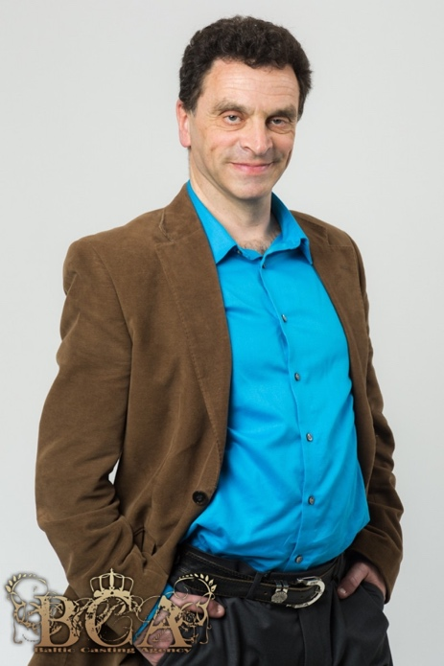 **M3225**

* Bachelor of Economics Monash University
* CPA
* Extensive training from Voice Over artist Abbe Holmes
* Training from the Radio Training Institute
* Listed on several Voice Over websites

**Recent Projects**

* For the past 5 years I have hosted 2 shows on local Portland community radio – 99.3fm.
* Voice overs for local sponsorship and community service announcements
* Voice Over for local independent movie trailer ‘Red and Black’ <https://www.youtube.com/watch?v=iwNIoNalQ_I>
* Narrator for local movie about the effect of climate change on coastal communities <https://www.youtube.com/watch?v=eGqFJZ-bew4>
* Narrator for You Tube animation – Flea in a glass jar

<https://www.youtube.com/watch?v=TK2Hd9a05HM>

* Narrator for You Tube film – The Narrator

<https://www.youtube.com/watch?v=SdT2kFjjQZE>

* Seven West Media - voice over about the Employee Shareholder Scheme
* Assetic – elearning videos on ‘how to’ use their software. I have produced to date well over 40 recordings for this client as well as their IVR.
* Elearning VO for Lingual Consultancy Services
* Elearning VO for BTS (Business Training Systems)
* Various promotional reads on Western Sydney Hip Hop (internet radio station)
* Audiobook – ‘Everyday Ethics’ now available on Audible

**Home Studio**

* Ability to produce high quality voice overs from my home studio with a quick turnaround
* I use Adobe Audition, have a Shure microphone and a portable booth (SE Reflexion Filter)
* I have a wide range in my voice with the ability to do characters or a narration.
* Voice Description – Warm, Authoritative, Trusting, Guy Next Door, Sincere, Believable