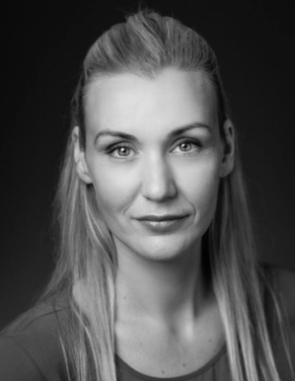 **M3176  
Hair:** Blonde **- Length:** Natural Long **Eyes:** Green **Height:** 5'9 (173cm)   
**Weight:** 59kg **Frame / Build:** Slim / Athletic **Nationality:** Latvian **Accents / Languages:** Latvian, Russian, English, American

**Film & Television Credits:**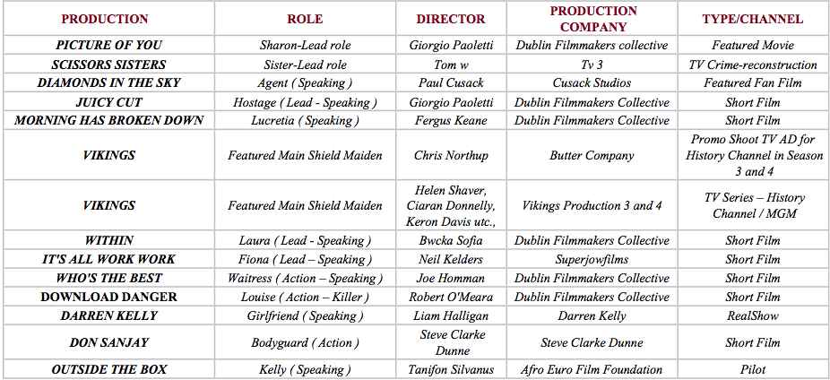

**Training**

* **2017** – Certified Stage Combat Course in Unarmed Combat, Rapier and Dagger Combat: The Lir, Tutors: Ciaran O'Grady IDCA
* **2016** – Acting Classes Course: Acting Classes in Dublin. Tutors: Terry McMahon
* **2015** – Workshop in Stage Combat Course in Unarmed Combat, Rapier and Dagger Combat: The Gaiety School of Acting. Tutors: Ciaran  O'Grady IDCA
* **2015** – Certified in Acting for Camera Term 2 + 3: The Gaiety School of Acting. Tutors: Pat Nolan + Tom Hall
* **2014 –** Certified in Acting for Camera Term 1: The Gaiety School of Acting. Tutors: Donal Courtney
* **2014** - Masterclass with Casting Director Gillian Reynolds in Dublin Central School
* **2013** – Workshop Acting for Camera: The Gaiety School of Acting. Tutors: Donal Courtney
* **2013** – Workshop Acting for Stage: The Gaiety School of Acting. Tutors: Donal Courtney

**Skills – Athletic**

* **Stage Combat:** Certified With The IDCA  
   Unarmed Combat. • Rapier & Dagger.

**Martial Arts:**

* P1 Grade in Krav Maga.
* Kickboxing.

Experienced in Ground Fighting, Falls, Sword, Sword & Shield and Axe Fighting. NRA Certified Basic Pistol Shooter. Certified in Archery. Experienced in Horse Riding, Skiing, Swimming, Jumping, Running. Fashion Show Modeling from 1997 to 2009 in Latvia and Ireland.