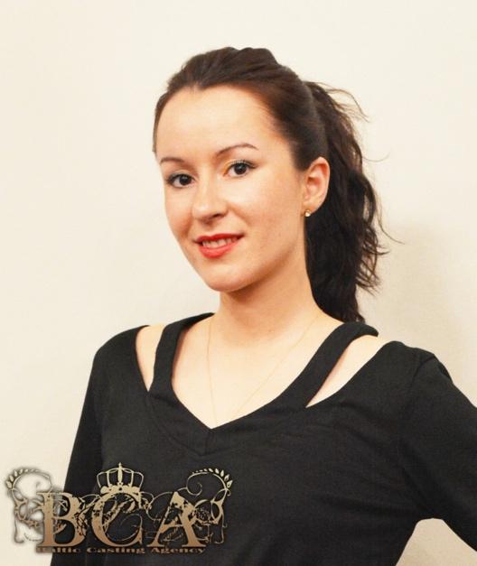 M3138

Height: 5'4'' (164 cm)
Weight: 8st 9lb (58 kg)
Chest: 34'' (86 cm)
Hips: 37'' (94 cm)
Shoe Size: 5 (38)
Dress size: 10
Waist: 27'' (74 cm)
Hat size: 22'' (55.9 cm)
Eyes: Brown
Hair: Brown
Playing age: 18-32
Vocal Range: Soprano, Mezzo- Soprano
General Dance Skills: Contemporary, Jazz, Folk
Instruments: Flute
Nationality: Latvian
Languages- Latvian, Russian, English
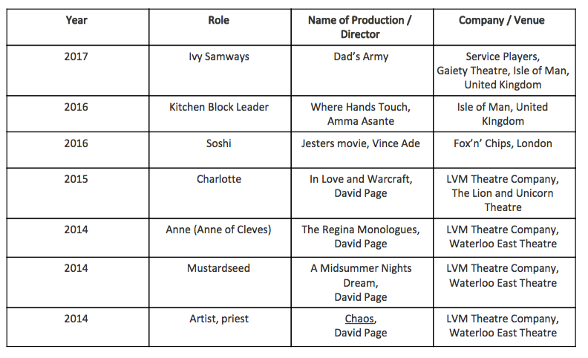

Education:
Dustin Hoffman Masterclass, 2017- current, online Acting for Screen and TV, Parker& Snell, 2016- 2017 Douglas, United Kingdom London Voice and Motion- Stage school 2013- 2015, London Westminster University- Mixed Media Fine art- performance art (First Class Honours), 2008- 2011, London Christian Highschool Theatre Group, Riga, Latvia 2003- 2005 (Theatre productions) Saldus Music School, Latvia- Choir Class (Singing, Solfeggio, Music History and Theory, Piano, Conducting) 1993-2000 Saldus Music School, Latvia- Flute 2001- 2003, Latvia

