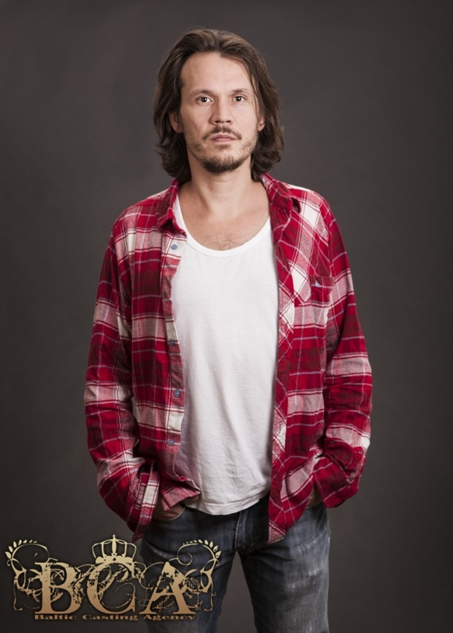 **M3095  
Personlig presentation:**

Rikard Svensson is most known for his 2 parts in "The Reunion" A movie that won the prize for best movie att "Guldbaggeglan" 2014(Swedish Oscars) and the prize for best movie made by a debutant at the Venice Film Festival. The movie was also among top 10 most seen movies in Sweden for several weeks. He is currently working with the movie "Dance First" as the lead actor, writer, and director and will also

bee seen in the swedish television series "Jordskott" in 2015 witch became a critic and audience success. And in 2015 he also participated in the movie "Audition", witch is Guldabagge-nominated for best short-film 2016. He is a skill full fencer and has made a lot of choreographies for stage combat. He is also very musical and plays a lot of instrument. And a proud father ot two kids.   
  
  
**Utbildning:**

Teaterhögskolan, Stockholm 1997-2001.   
Svensk högskola på scen och filmområdet

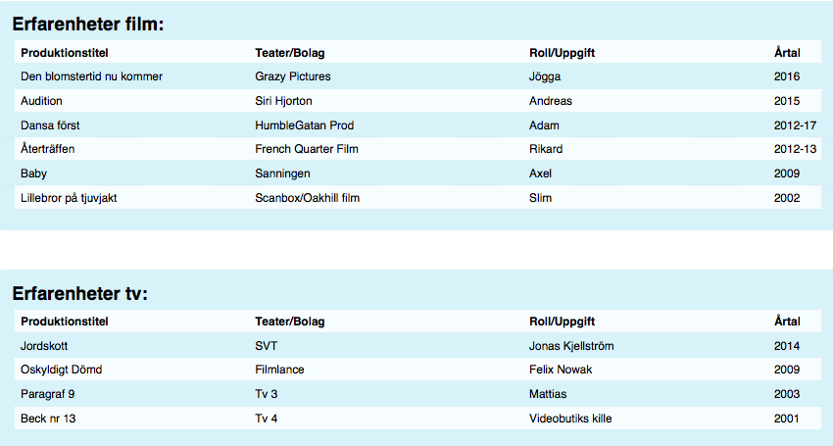

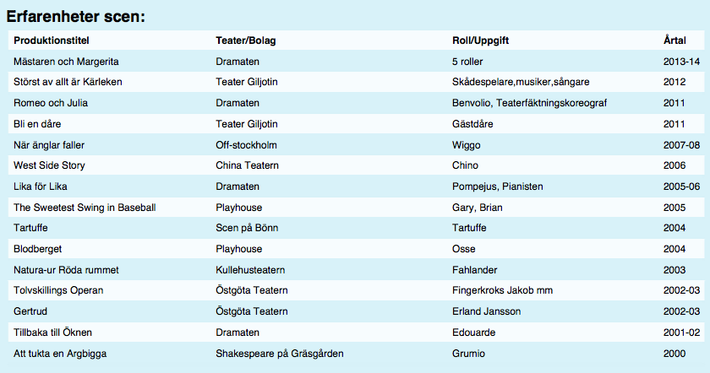

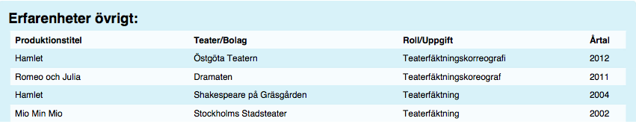  
  
/Users/gita/Desktop/Screen Shot 2017-08-04 at 11.52.41.png