 |  | M2530
Curriculum Vitae
 |  | 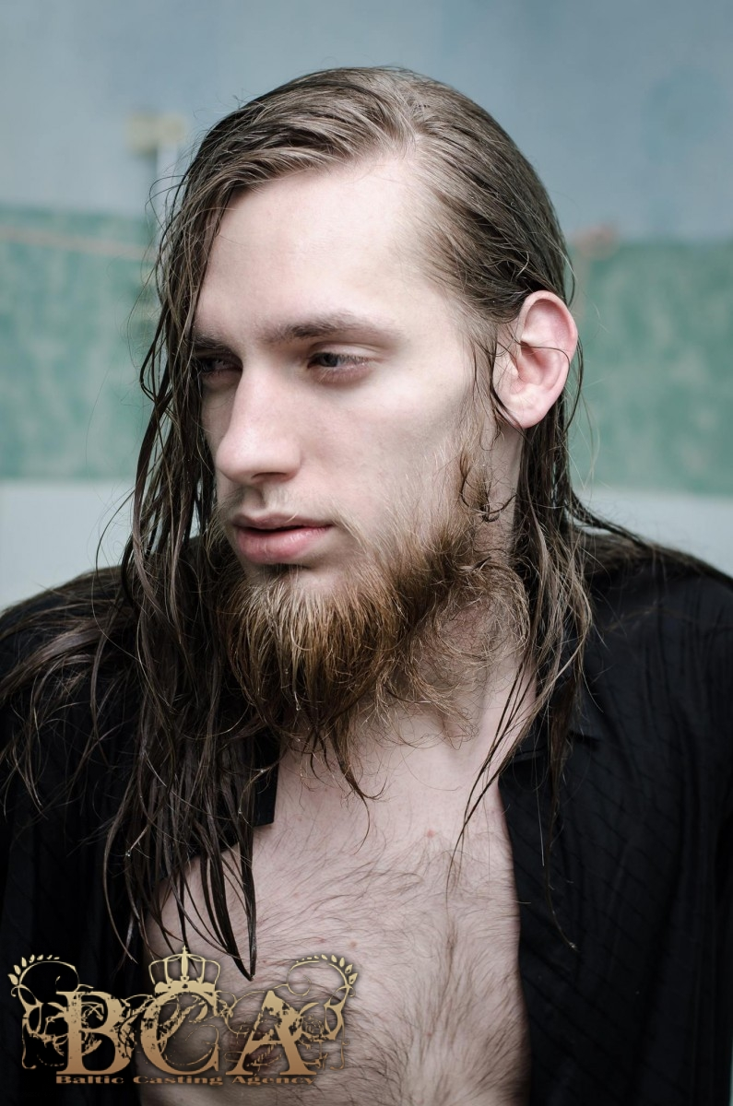 M
Personal information |  | Kaunas, Lithuania
 |  | 1991 08 27
Work experience
Dates |  | 2016 05 – 2016 12 consumer services assistant at Callcredit Information Group ( Kaunas )  Resolving data disputes via contact with data providers, working with sensitive data.  2013 12 – 2014 02 sales manager at “Telemarketing Professionals“  A good experience – learning how to negotiate, react quickly, communication. The job is done only by phone.  2015 08 01 life insurance broker at ERGO Life Insurance SE  Searching for new clients – choosing an insurance plan suitable for their need, interacting by phone, and in person.
Education and training
 |  | 2010-2015 Kaunas University Of Technology
Bachelor of applied mathematics. My profile is called “modelling of business systems”
theme of thesis is “ pharmacokinetic modelling using hybrid automata”
Generally, a student of applied mathematics is suited for analysing any data of a company, solves various practical problems that require a mathematical approach, and is able to quickly adapt to new tasks and learn new things.
Some examples of studied modules: stochastic processes, data analysis, numeral methods, basic programming C++

1998-2010 S. Darius ir S. Girėnas gymnasium

My exam results : Lithuanian language – 51% mathematics – 86% English language – 95%

2007-2010 Kaunas art school of A. Martinaitis
 |  | 2014 04 – 2015 02 – Italian language courses at “Ciao Italia” ( with certificates )
Personal skills and competences
Mother tongue |  | Lithuanian
Other languages
Self-assessment |  |  | Understanding |  |  |  | Speaking |  |  |  | Writing
European level (*) |  |  | Listening |  | Reading |  | Spoken interaction |  | Spoken production
English |  |  |  | C2 |  | C2 |  | C2 |  | C2 |  | C2
Italian |  |  |  | C1 |  | C1 |  | C1 |  | C1 |  | C1
Egyptian Arabic |  |  |  | B1 |  | B1 |  | B1 |  | B1 |  | A1
German |  |  |  | B1 |  | B1 |  | B1 |  | B1 |  | B1
French |  |  |  | B1 |  | B1 |  | A1 |  | A1 |  | A1
Hebrew |  |  |  | A1 |  | A1 |  | A1 |  | A1 |  | A1
Computer skills and competences |  | Basics of C++ ( MS visual studio ) , SAS statistical analysis software, MS EXCEL – macros, some self-taught basics of Adobe Photoshop, FL studio and Adobe Audition.  generally good with computers, I can learn new things that are necessary for a job easily.
Artistic skills and competences |  | 2014 09 – 2015 01 the theatre of Kaunas University of Technology “44”, actor of minor role.  2012 02 – 2012 04 Kaunas University of Technology television “Kobra TV”  2015 – present, photomodeling ( few catwalks ), not a professional modelling, more like a hobby, but I consifer myself a good, expressive model.  2016 06 – self-taught photographer
Generally about me |  | I am a rational thinking, expressive, impulsive, straightforward, honest, positive, generally funny person.

