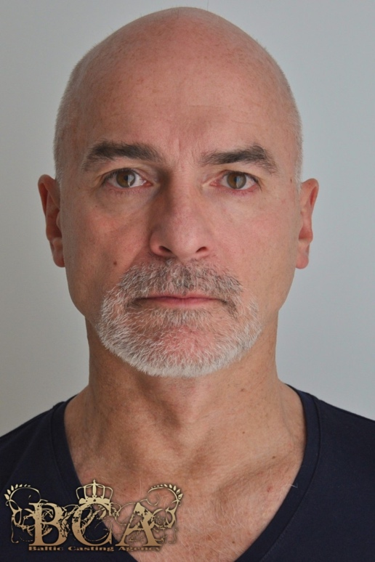 **M2493**Born 5 January 1961   
Race Caucasian   
Height 179 cm / 5 ft 11”   
Weight 75 kg / 165 lb   
Hair Grey / balding   
Eyes Brown   
Residence London, LA

**Film**

“The Forgotten One” (“Major Jeffreys”), 2016, in post-production “Over the Top” (“Captain Withers”), 2016, in post-production “Crossing the Line” (“Terry”), 2015, independent release   
  
**Training**

Acting for Camera ̶ ActorsVision School of Acting, London & Cork   
Workshops & Tuition   
Epic Combat Masterclass - Ciarán O'Grady (Irish Dramatic Combat Soc.) Audition & Performance Masterclass - Clair Sinnett (Actors Working, L.A.) Voice and Accent Masterclass - Brendan Gunn Private Tuition - ActorsVision School of Acting, London & Cork

**Special Skills**   
**Languages**

Accent-free French, German, Italian, Spanish and Portuguese Basic Russian and Arabic Various English regional accents and dialects, foreign accents in English, regional dialects in the foreign languages spoken, as well as various English accents in foreign languages   
  
**Voices**Distinctive and resounding voice Wide range of voices, imitations and impersonations   
  
**Music**

All keyboards, drums, flute, guitar and singing (range from Bass-baritone to Tenor)

**Sports**

Expert in Equestrianism, Track & Field, Swimming, Alpine and Water skiing, Wind surfing, Tennis, Squash, Badminton

**Martial Arts**

Stage Combat, Judo, Taekwon-Do, Boxing