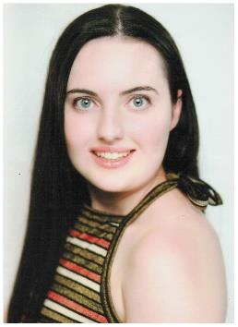 **M2489**

DOB: 7th march 1997 Ht: 148cm Wt: 52kg Nationality : Australian

**CURRENT OCCUPATION:**  Student – youth work

**QUALIFICATIONS:** Completed VCE 2015 , Diploma in Television and Film Acting

**TRAINING:** Tanya Powell Melbourne   
  
**EXPERIENCE:   
Films & TV Drama**Neighbours – 2016   
The Leftovers -2016   
Edge of the Bush-2016   
  
**AMATEUR THEATRE / PLAYS:**

VCE drama, year 12 solo played the character of Charlie Feehan –   
( won both the academic and endeavor drama award in year 12)

**INTERESTS / HOBBIES / SPECIAL SKILLS:**

Babysitting , working with people especialy young people , shopping , volunteering , going to the gym , walking my dog ,

**MUSICAL INSTRUMENTS:**

Flute