**M1447**

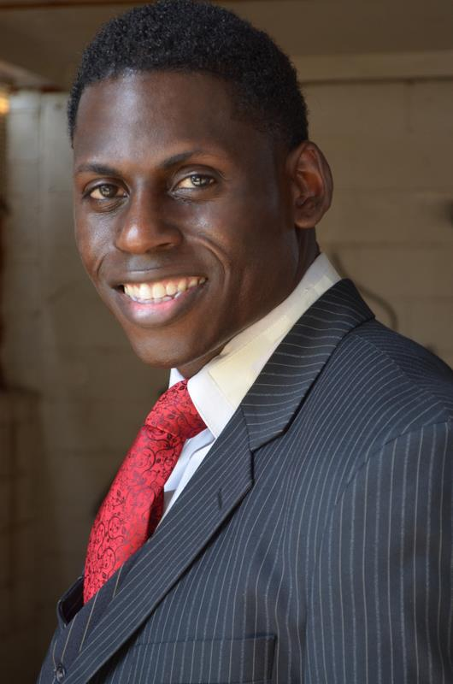 **M1453**

Model/Actor/Dancer/Mime/Instructor

This actor was born and raised in Daytona Beach, FL to Jean Grant Miley and David Lee Carter II at Halifax Hospital, and presently resides in Atlanta, GA. Matthew is a well-rounded young man and has enjoyed art since he was a child. As he got older he explains that he began to see the human body itself as a work of art. Matthew says, “I’ve always wanted others to see me as a work of art in pictures and in person. This was the breaking point for me, and soon it began to really stir up and create more of the desire to become a famous model”.

He soon began to perform in various clubs around Florida and small modeling jobs after graduating high school. This helped him to mold his image and desire to want to become a model even more. Performing in different clubs is what gave him the courage and experience to act and model for a wide variety of audiences, and has also helped him to develop different techniques to prepare him physically and mentally before a show or performance. Matthew has been seen in more than a dozen fashion shows, appearances as an extra in movies, talk show appearance, promotional modeling, and he’s appeared in a host of other forums to build his portfolio and resume. He is a hardworking, dependable, and trust-worthy individual that certainly has the desire to be successful and provide a better life for himself and his family.

This actor attended First St. Peter A.M.E. Church in Stone Mountain, GA where he was the President and Director over the Dance and Drama Ministry. Matthew now attends Love Fellowship Church International in Jonesboro, GA where he is over the Sacred Arts division. He attributes his success this far to having a positive attitude, determination, passion and prayer; which he says these combinations of things have been the fire in his belly.

With the experience and wisdom he has gained, he decided to start a Christian based Non-profit organization of his own to assist others who truly need and accept his help. A Real Desire is the name of his organization, and is building day by day. With this organization he says, “After being told by my doctor that I would die of AIDS I renounced death and claimed life. I decided to not die with AIDS, but to LIVE with it, and with Gods help I will help who I can, when I can, while I can, before God calls me home.” He has truly dedicated his life to Christ and has made it his mission to help his fellow man with the hope of inspiring others to jump aboard.

Stats

Height: 6’1” Weight: 185lbs Hair: Black Eyes: Dk Brown Suit: 40L

Chest: 39 Waist: 32 Out-seam: 42 1⁄2 Over-arm: 47 Under-arm: 40

Neck: 16 1⁄2 Sleeve: 35 Hip: 39 Vest: MD Shoe: 12 1⁄2

Fashion Shows

Urban Wear  Runway

True Vision  Runway

Visual Erections Runway

All White Affair Runway

Kinky in the Ham African Hair Show/Runway

Bronner Brothers Hair Show/Runway Runway

Model Productions Runway

Dream Kweens Movie Premier/Runway

Ladies of Now African Fashion Show

Africaine Pinkfest Breast Cancer Fashion Show

Miss Georgia Album Release Fashion show

Le’unamme Runway/Couture

Dee Hill Designs Utopia Fashion Show

Urban Network Network Friday Fashion Event

Wet & Wild Runway  
Special FX  Hair Show/Runway  
G&G Promotions Runway

Film/TV/Commercial

Operation Dead 1  Zombie

The Debra Gatlin Show Model

Kiente’ CBS T.V. Segment Model

Fast and the Furious 7  Stand-in

The Haves and the Have Not Extra

Single Ladies  Extra

Bliss Music Video  Dancer

Sam Music Video  Dancer

Drop Dead Diva  Bailiff

Drop Dead Diva  Groomsmen

42 (Movie)  Sports Fan

Hunger Games 2 (Movie) P. Guard

Things You Should Know Scientist

Kill the Messenger (Movie) Journalist

The Game  Extra  
Necessary Roughness Photographer

Productions

Model Productions Talent Show

A Real Desire Presents Talent Show

A Real Desire Christmas Party Fashion Show

Model House TV Fashion Show

Promotional

Attack Marketing Sears

Marvel  Spiderman

Beloved Experiential   Coca-cola

Attack Marketing Go West Go Wild

Beloved Experential Pixman

Beloved Experential TBS

Beloved Experiential  Coke Zero

GMR Marketing New Balance Total Fit

Print

Ebony Flare

Roca Wear

Dubb Magazine

Black Inches

Performing Arts Experience

Community Theatre The Day That Jesus Died

Community Theatre Misconception of Love

School Play  A Christmas Story

Church Play The Day Jesus Was Born

Mime/Liturgical Dance Ministry In Action

Interest

Interior Design, Sewing, Clown/Comedian, Improvisation, Impersonations, Travel, Acting, Modeling, M.C., Drawing, Dance/Praise Mime

Special Needs

Glasses, Contacts (clear/color)

Piercing

Left ear and tongue

Scars  
Left side, chest, back of neck, right eye