M1447

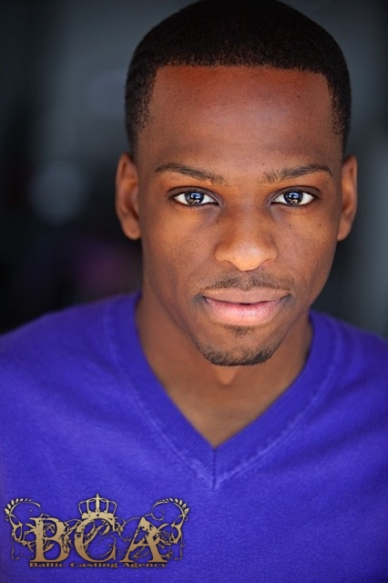 Height: 5’7 Weight: 145 LBS Hair: black Eyes: Brown   
  
  
 