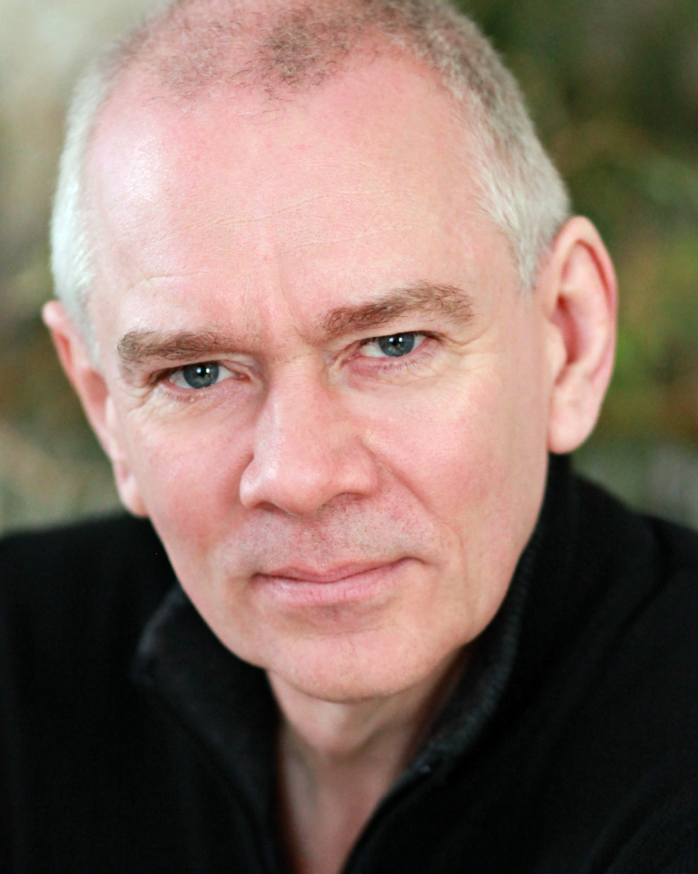**M1417**

Plays 50 – 58 5’9” 11.5 stone / 73kg Medium Build.

He was a professional actor in the 1980’s, then went on to run a corporate role play company until he sold it in 2012. He’s now relaunched as an actor and voice-over artiste.

**Work & Training in 2014 & 2013.**

Grandfather OnLine Commercial AmbiWarm Heating Thirteen Disciples.

John Video Promo Inchbold Design School Cavendish Fante Prods.

DJ Ray Ray Radio Middx Uni VoiceOver

Narrator OvenKing Animation PetersProVideo VoiceOver

Father Haggard Act of Contrition Ravensbourne College Grad film

Dad & Demon Two Evils Christop Younes Animation voice over

Narrator Liars League Liars League London Live Story Readings.

Mr Steward Occupied Hearts FFP New Media German TV

VoiceOver EDI Recruitment Website www.jewelboxsound.nl

Earl March Tamlin – Feature Film www.fairytalefilms.co.uk

Einstein Website Narration Healthier Entertainment Industry

MC Cabaret Gaia Annual Cabaret Gaia Camp

Boatman Student Film audio Wondrous River Wimbledon College of Art.

David Sachs Rehearsed Reading The Last Christmas The Space Between Words

Monty Audio All Our Yesterdays Peracals Productions.

*Training at the Actors Centre, Actors Platform, The CityLit, The Showreel.*

**Work & Training in the 1980’s – highlights;**

Various roles The Bill Tech Training Film Thames TV

King Matalome The Miracle Child Tour Upstream Childrens Theatre

Mole Wind In The Willows Tour Charles Hayley Prods

Tom Man With The Hoe Old Red Lion Loose Exchange Theatre

Pickpocket Eastenders TV BBC

Ambassador Revo Tour Umoja Theatre

Gary Roots Me Roots Tour Roots Theatre Co

Policeman Manon Royal Opera House Royal Opera House

Various Dei Fledermaus Royal Opera House Royal Opera House

Various The Roach Show Cabaret Approach Tavern

*Training at Oval House, Battersea Arts, Drill Hall, City Lit.*

**Role Plays For Training : 1988 – 2011, My own company, Corporate Role Player;**

Over 1000 role-play days, many corporate conferences as performer, numerous training videos.

**Skills;**

Writing & Devising, Quick Improviser, Voice-Over with Home Voice Studio using Pro Tools and Rode mic, Clean Driving License.